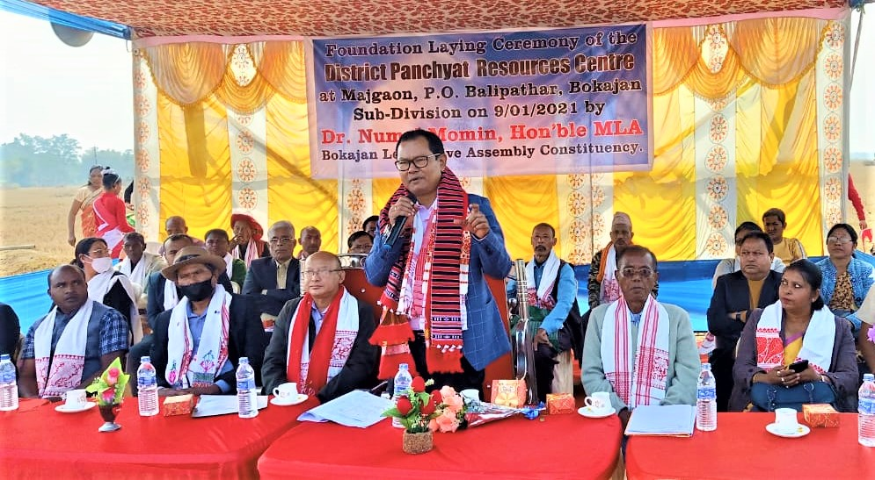
Foundation laying ceremony of DPRC at Bokajan
9th January, 2021 is a historic day for the people of Bokajan and also for the State Institute of Panchayat and Rural Development, Assam (SIPRD) as the foundation stone of the District Panchayat Resource Centre, Bokajan was laid by the honourable MLA of Bokajan constituency Dr.Numal Momin at Majgaon, Balipathar, Bokajan.This centre will definitely help the people to get the knowledge in the field of Rural Development and also to help strengthen the Panchayati Raj Institution of the area. This will help people to come forward and will guide them to build up their capacity to participate in the development process to make their villages developed and beautiful.

