JOINT SECRETARY,MOPR, VISITED SIPRD,ASSAM
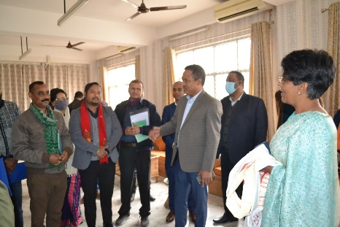
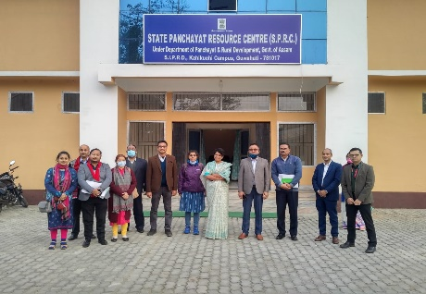
Mrs. Rekha Yadav, Joint Secretary, MoPR, GOI had visited SIPRD from 21st January 2021. She was given a warm welcome by SIPRD officials led by Sri K. Pegu, ACS, Director, SIPRD. During her stay at the HQ on 21st January, She had discussion with Director and Joint Directors of SIPRD and other officials and she was briefed about the progress made under various schemes and trainings through a power point presentation.
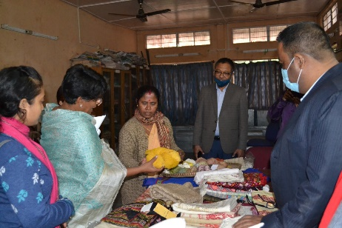
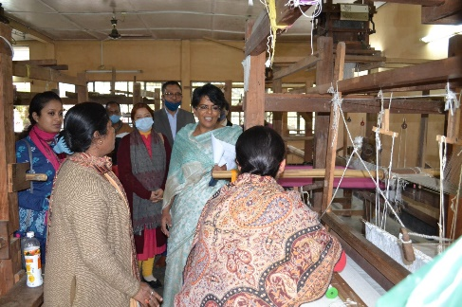
Later on the day, She had interaction with SIPRD officials and Faculties at Kahikuchi , the second campus of SIPRD and also inspected the infrastructures developed under RGSA, took stock of the process of GPDP both in PRI and VCDC areas. For first hand information and progress regarding GPDP, she had visited one GP of Kahikuchi area under Rani development block and next day visited SIPRD, Kajalgaon and one VCDC in Kokrajhar area .

