Sri Munindra Sharma is the new Director of SIPRD, Assam
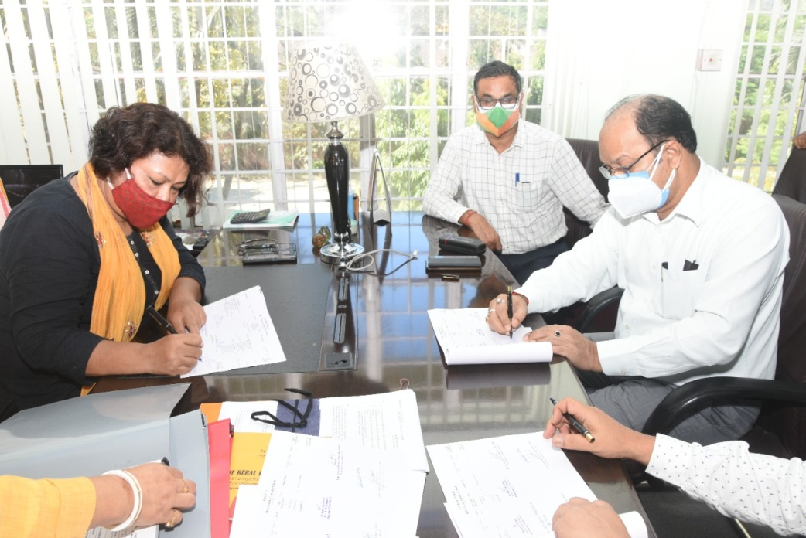

Sri Munindra Sharma,ACS, Secretary,Panchayat and Rural Development Department, Govt.of Assam has taken the additional charge as Director, State Institute of Panchayat and Rural Development from Smti Juri Doley,ACS on 12th July,2021 at SIPRD,HQ,Khanapara. Sri Pabitra Kalita, Joint Director,SIPRD welcomed the new Director Sri Munindra Sharma to SIPRD Assam and also thanked former director Smti J.Doley for her guidance and cooperation during her tenure. The formar director thanked the officers and staff of SIPRD for the cooperation she received and thanked them for that.
Sri Munindra Sharma in his speech, thanked everyone for the love and affection shown to him and also said that he will do his best for the institute and always expecting help and cooperation from everyone in this regard. The vote of thanks was given by Sri S. Borgohain,Jt.Director,SIPRD.

