Best Practice under GPDP
A Maternity ward at Bekajan Mini PHC

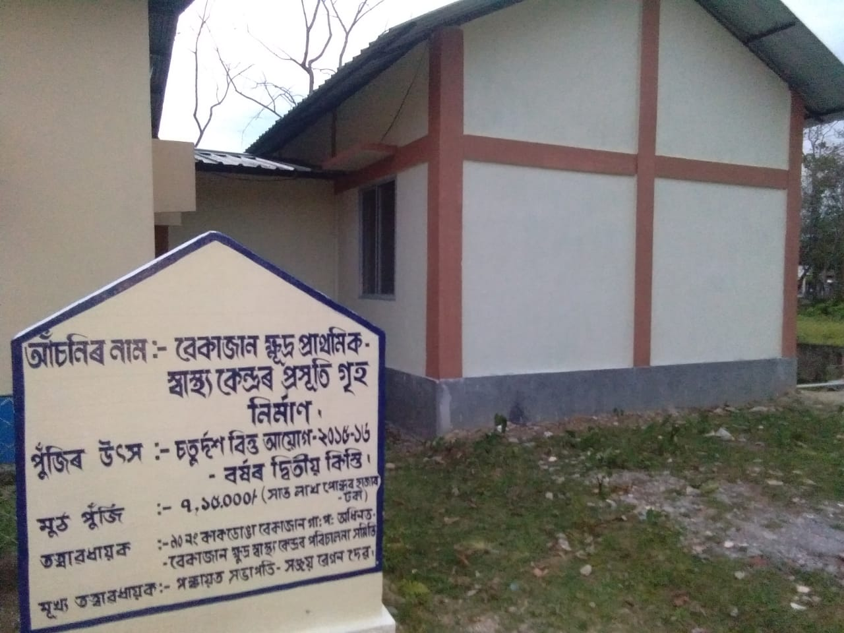

A long felt need by the people living under the 90 no Kakodonga Bekajan Gaon Panchayat under Titabor Development Block of Jorhat district has come into reality after the construction of a Maternity ward building at Bekajan Mini Primary Health Centre. The building has been constructed under the Fourteenth Finance Commission fund for the year 2015-16.
The village people of this area have already heard the name Amar Gaon Amar Achoni, which is the new hope for the people living in villages of our country. As per the new policy of the Government, the GPDP is currently under way which has given the power to the people living in the village area so that they can select and prepare their own plan of development.
The Bekajan Mini PHC has been rendering its services to about 1991 families residing in the fourteen villages under its jurisdiction. The rate of child birth is about 6 per month and the patients used to go to Borhola, which is 13 kms away, for better treatment and delivery. There are only four Asha workers in the villages who cannot provide service to all the people of this remote village. Situated in the Assam Nagaland border, it was the most urgently felt need and therefore selected by the ward sabha and later on by Gaon Sabha on priority basis.
At present though it is not yet ready for use,it is hoped that very soon the villagers will get benefit from this Maternity room attached with the Bekajan Mini PHC. It is expected that about 80 women of these villages will get benefit from this new Maternity ward in the coming days.

