Supply of electricity from Floating Solar Panel

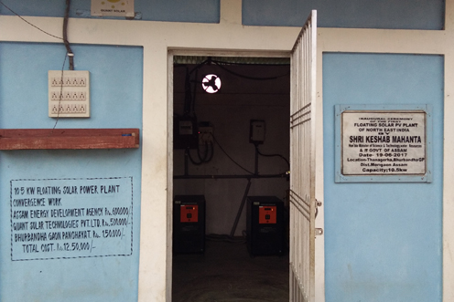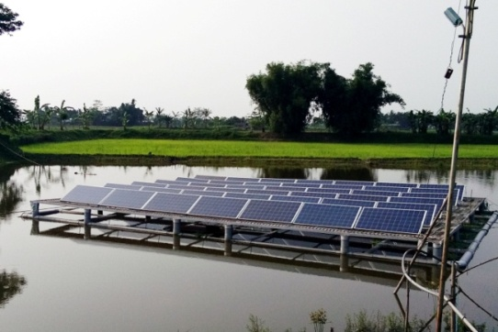
The people of Thanagora, a cluster of twenty families are mostly agriculturist. Living in a flood prone area, they have never enjoyed the electric light in their life. The school children always used to read under kerosene lamp or candle. Though the area is not too far from Morigaon town ( only 13 km) this was the way of life for those families.

However, since last year, the scene has changed due to the initiative taken by Bhurbandha Gaon Panchayat. The convergence of three major stakeholders like Assam Energy Development Agency, Quant Solar Technologies Pvt.Ltd and Bhurbandha GP have installed a floating solar plant in a pond of the village which has been producing 10 KW of electricity from last year. The project cost was 12.5 lakhs, of which the Assam Energy Development Agency spent Rs 6 lakhs, Quant Solar Technology spent 5 lakhs and the Bhurbandha GP spent Rs.1.5 lakhs. It was inaugurated by Hon’ble Minister, Science and technology and Water Resources department Sri Keshab Mahanta on 19th June,2017.

As the President of the Bhurbandha GP , Sri Bhupen Deka said, the whole area is flood prone and always submerged their crops by flood water. Due to this reason the project is designed and installed in a fishery in such a way that it never get submerged. The electricity produced is distributed to twenty families of the village. Each family getting electricity for lighting three LED bulbs and a Fan. To maintain the whole thing a village committee has been formed with Nazir Hussain as president. For electricity supply each family has to pay sum of Rs 200 per month.

Besides lighting up the homes of twenty families the electricity is also used for street lights. A portion of electricity is also used for circulating the water of the fishery by using a sprinkler. This has increased the oxygen content of the water which helps to increase the fish production.

