Water purifying plant at Kadong GP
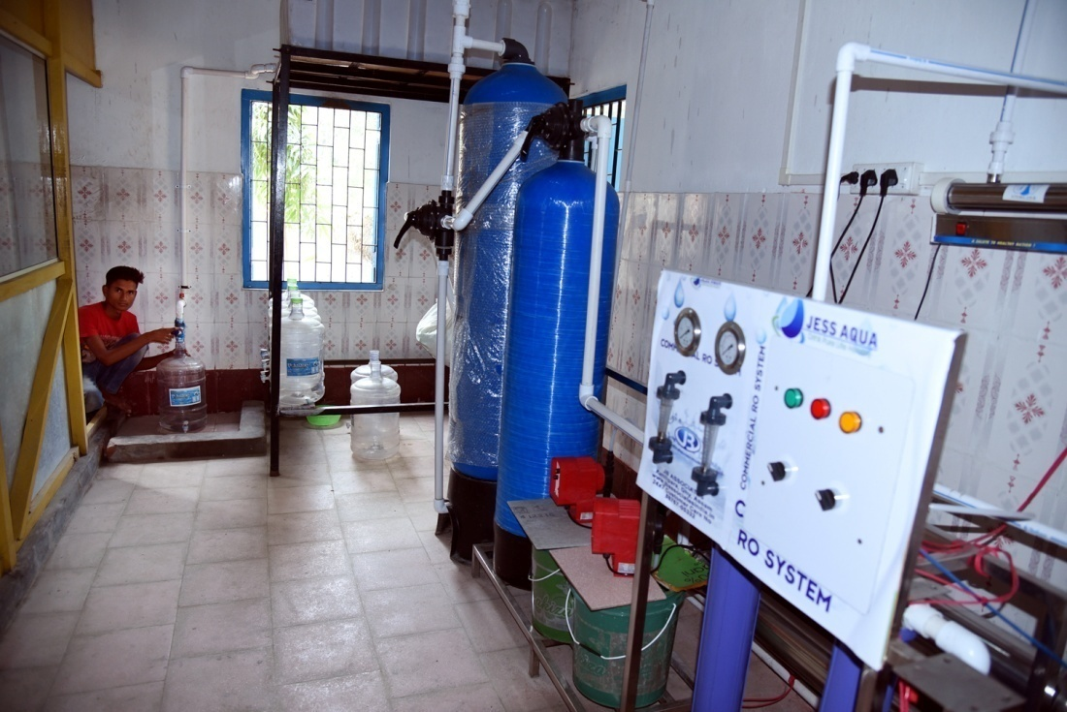
The 79 no Kadong GP under Mandia Development Block of Barpeta Zilla Parishad has implemented a scheme under 14th finance commission for the year 2015-16 and installed a water purifying plant for the benefit of the people of five villages under the panchayat. The estimated amount for the scheme is Rs 7 lakh (1st instalment). The estimate for the project was framed by technical staff of Mandia Development Block as the demand for pure drinking water in the GP was an urgent need for the people.
The Panchayat has branded the purified water under the name Beki Aqua and stored the water in 20 litre jar for domestic as well as commercial use. The people of the panchayat buy the 20 litre water jar at Rs 20. This has greatly benefitted the people as the use of pure drinking water in their daily life is most essential and using the pure drinking water has also lowered the spread of water borne diseases among the people. The Panchayat has also able to generate their income through selling of the water to the people directly and through the market.
The plant was inaugurated by Sri Mahmood Hassan,ACS,CEO of Barpeta Zilla Parishad in presence of Smti Lilima Khatun,President,Kadong GP on 02-02-2017.

