Construction of Market Complex at Jania G.P.
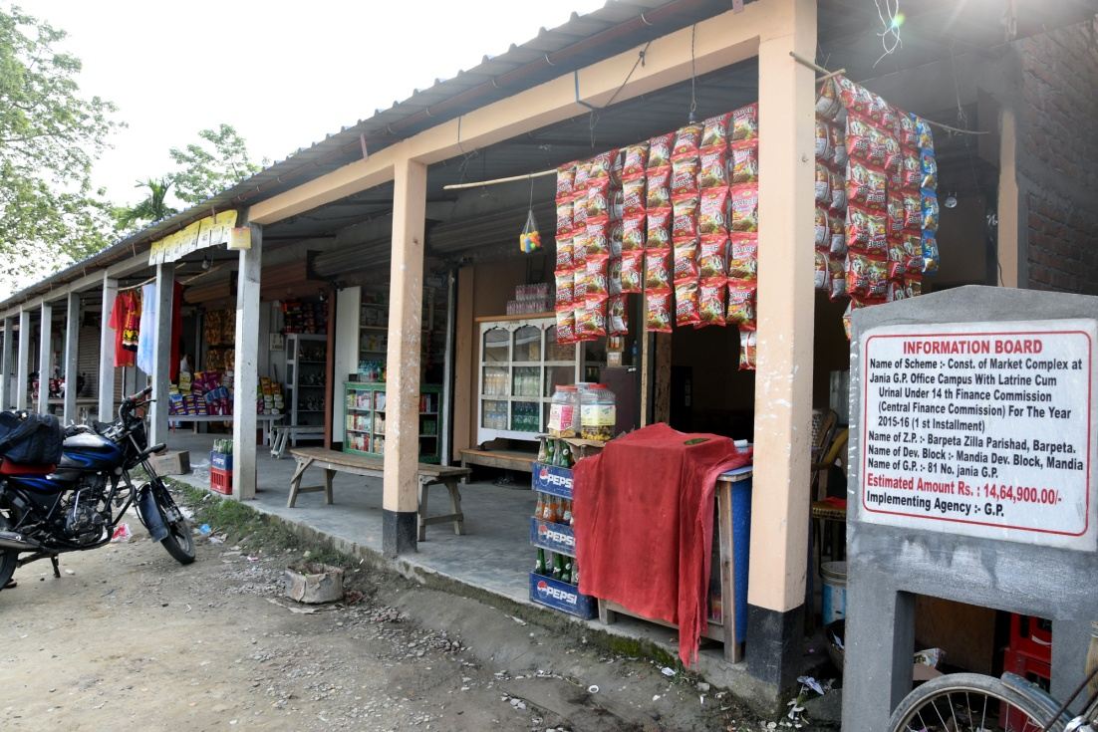
By using the funds under 14th Finance, the Jania GP, under Mandia Development Block and Barpeta Zilla Parishad decided to construct a market complex in the campus of Jania G.P. in the financial year 2015-16. A provision to construct a latrine and Urinal also proposed in the plan and for this a sum of Rs 14,64,900 was sanctioned ( 1st Installment).
After completion of the complex the shops are rented out to private parties for commercial shops etc. By this way the GP has been successful to earn finance which is very much helpful in strengthening the resource position of the panchayat.

