Preservation of Folk Culture by Manaha GP
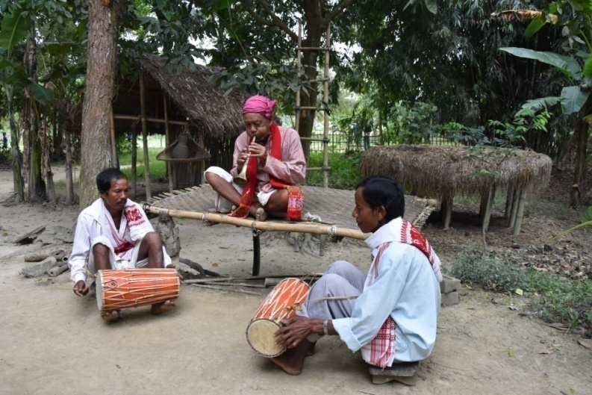
The Monoha G P has initiated a programme under GPDP to conserve folk art tradition of the region and under this they have established a music school cum recreation centre named as Sontora club. The region is boast of its one and only KALI player, 90 years old Megha Singh Ingti. As he is getting old so this traditional music has to be preserved and should be learnt and carry forward by the new generation. With this view in mind they have started the music club at Hatiutha village. The panchayat has arranged and brought musical instruments for the club. The GP secretary said that regular classes are going on in various folk music including Kali so that this beautiful music could be preserved and the new generation can learn the music.
There is also a tradition to felicitate senior persons and freedom fighters of the region under the initiative of the Gaon Panchayat on various occasions like Independence Day, Republic Day etc. Sri Megha Singh has also got a chance to inaugurate the official function of Gandhiji’s birth anniversary on 2nd October, 2016.

